Green Society Public School
D-21
Ratnanagar-7, Sauraha, Chitwan
Third Terminal Examination-2082
Class: Nursery Time: - 2 hrs. F.M.: 50
Sub: Maths ‘O’
- What is your name? 5
- How are you? 5
- In which class do you read? 5
- How old are you? 5
- Say (1 to 30) 10
- Say (!–@)) 10
- Read the following numbers? 5
11 12 13 14 15
- Identify the pictures. 5

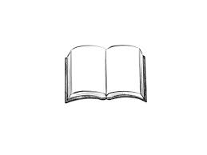

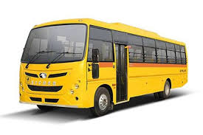


The End

